**Windows and Frames**

1. Write a Selenium script to automate the following task:

* Open a new instance of the Chrome/Firefox/Safari browser.
* Navigate to the URL "https://the-internet.herokuapp.com/windows".
* Click the "Click Here" button to open a new window.
* Switch to the newly opened window.
* Verify that the text "New Window" is present on the page.
* Close the new window. 7. Verify that the original window is active.
* Close the browser instance.

Code:

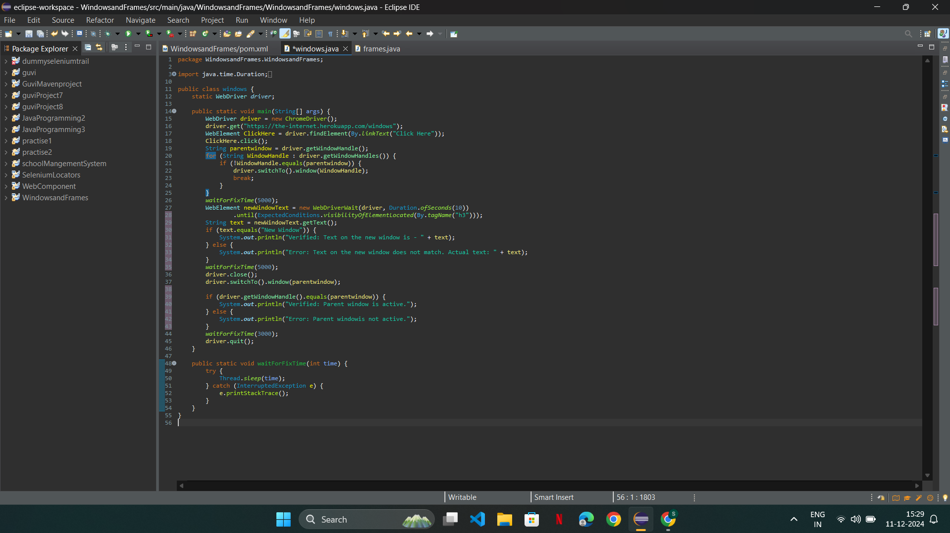

Output:

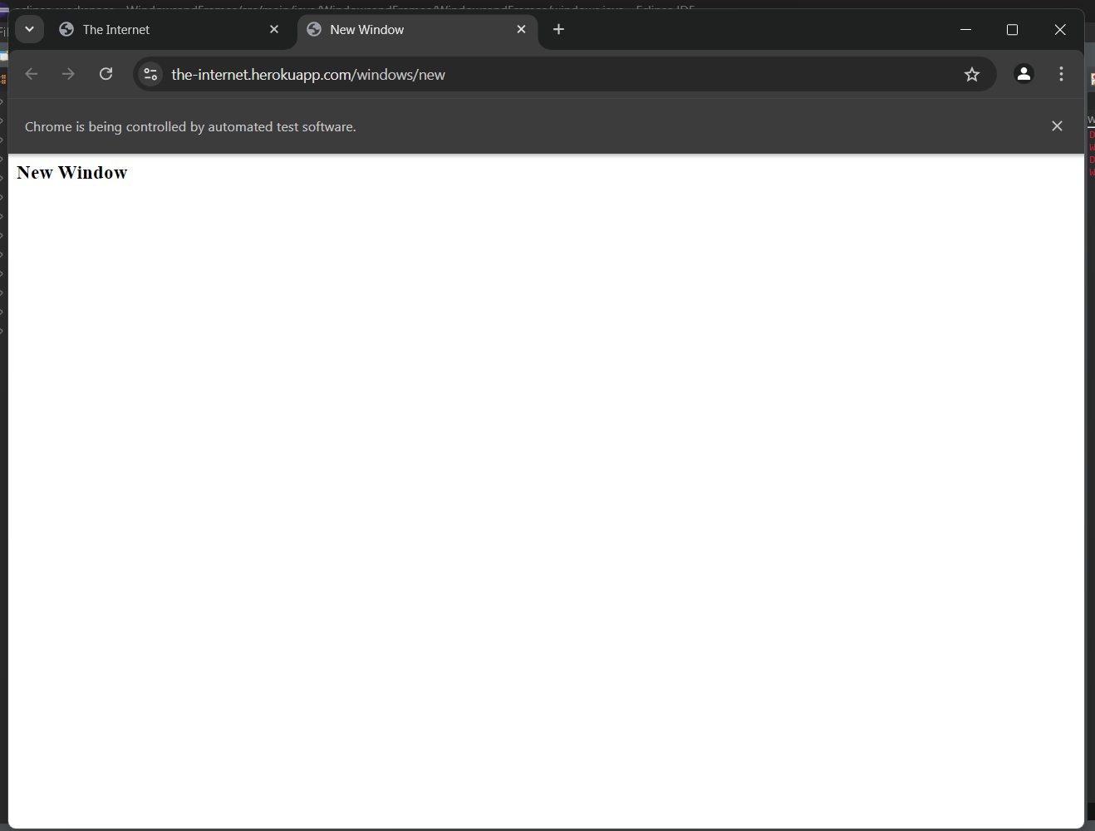

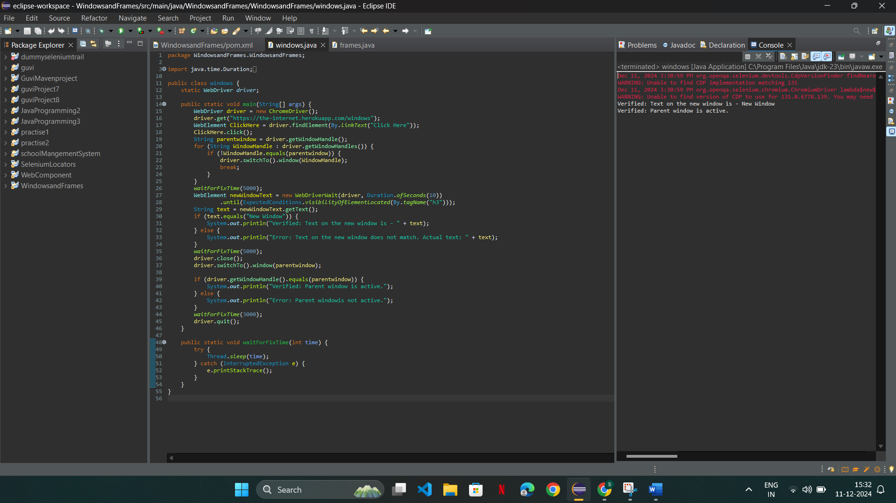

2. Write a Selenium Java code to automate the following scenario:

* Open the URL http://the-internet.herokuapp.com/nested frames
* Use only css selector or Xpath. Switch to the top frame.
* Verify that there are three frames on the page. Switch to the left frame.
* Verify that the left frame has a text "LEFT". Switch back to the top frame. Switch to the middle frame.
* Verify that the middle frame has a text "MIDDLE". Switch back to the top frame. Switch to the right frame.
* Verify that the right frame has a text "RIGHT". Switch back to the top frame. Switch to the bottom frame.
* Verify that the bottom frame has a text "BOTTOM". Switch back to the top frame.
* Verify that the page title is "Frames".

Code:

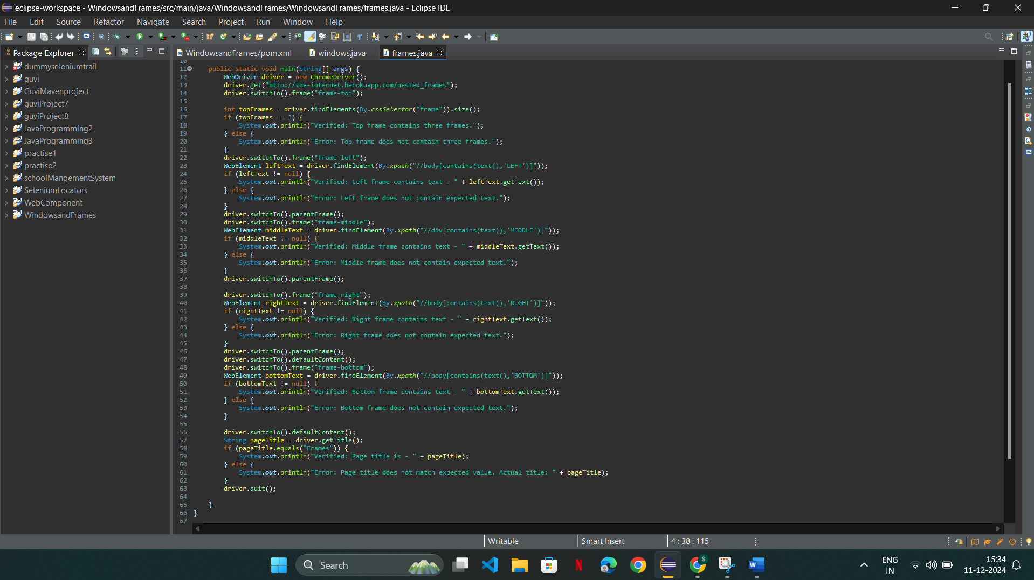

Output:

